**Recognition Points to Cash**

1. Redeem **Giftaway** Gift card. ([Giftaway Universal | Store (workhuman.com)](https://cloud.workhuman.com/store/" \l "!accenture/products/URLGIFRFCG))  
   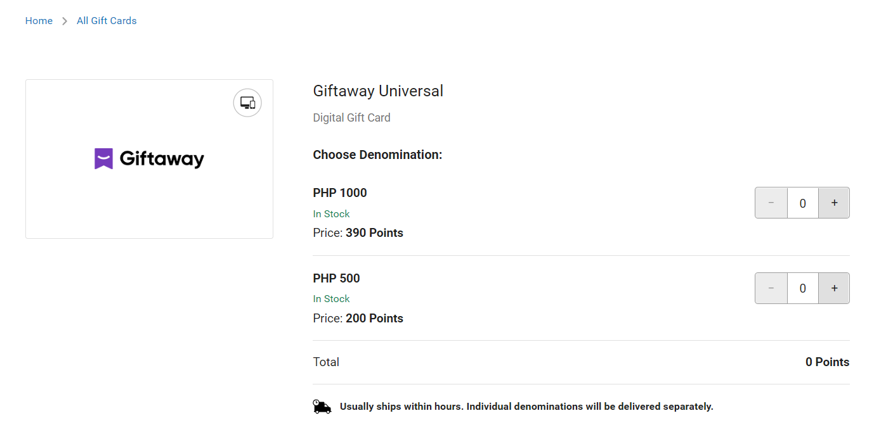
2. Open **Shopee** App > **ShopeePay** and select **Cash In**.

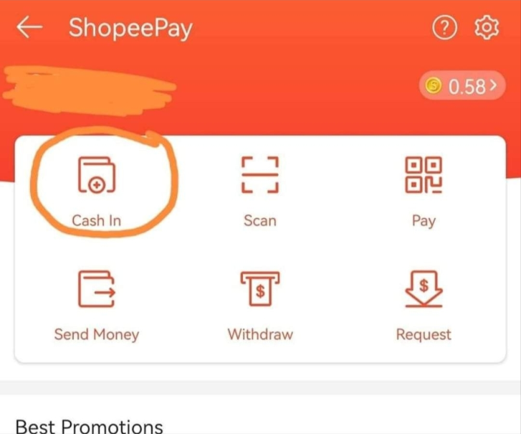

-Select **Payment Center/ e-Wallet** > **ECpay** and **Confirm.** 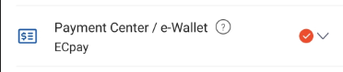  


-Select the amount and click **Pay Now**. *(This is limited for 500 and 1000 per transaction only?)*  
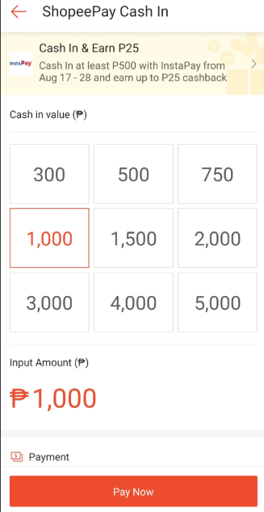-Payment confirmation will appear, and you can copy the reference number.  
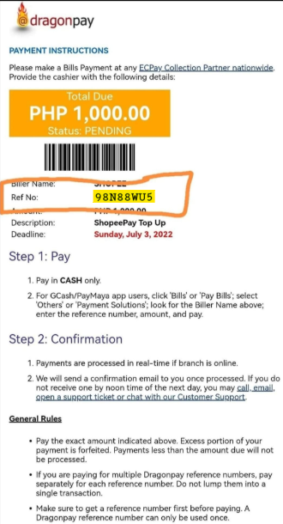

1. Next, open the link: <https://coins.giftaway.ph/shopeepay/redemption> and paste the Shopee Receipt **reference number** and **e-Gift Code** (screenshot provided below), respectively.  
   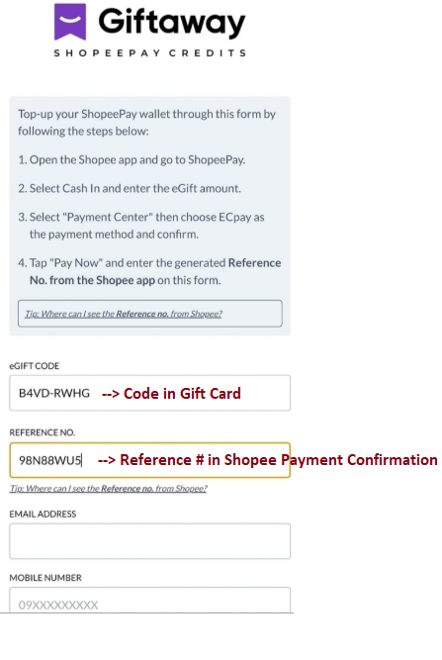  
   -eGift Code  
   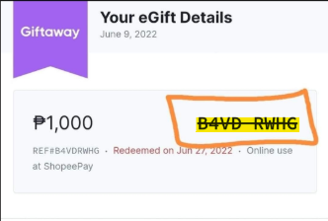
2. After the successful transaction, you can transfer it in your bank, gcash and etc.